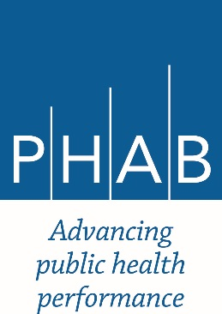 | Public Health Accreditation Board  Data Request Form  Effective Date: January 1, 2016

In order to request the use of accreditation data, please complete this form and email it to jkronstadt@phaboard.org. Additional information about PHAB data is available at http://www.phaboard.org/research-and-evaluation/. If you have any questions, please contact Jessica Kronstadt, Director of Research and Evaluation.

- Lead Researcher:
Name:
Organization:
Email:
Phone number:
Address:

- Other members of the research team. (Please list all other individuals who will have access to the data set.)
Name:
Organization:
Name:
Organization:
Name:
Organization:
Name:
Organization:
Name:
Organization:

- Project title:

- Briefly describe the purpose of the study. What research question(s) does the study seek to answer? What specific hypothesis are you testing?

- Briefly describe the study design, methodology, and analysis plan. What other data, if any, will be merged with the PHAB data? What statistical analyses will be conducted?

- What is the funding source for the study?

- Which data elements are you requesting? Please refer to the Description of PHAB Data and Codebook for field names (available at: http://www.phaboard.org/research-and-evaluation/).

- Are you requesting that the data set include the name of the health departments? If so, why?

- What steps will you take to protect the confidentiality of the health departments throughout the research process?

- Has this study been reviewed by an Institutional Review Board?

- What is the anticipated timeline for the study?

- How do you plan to disseminate the findings?

By signing below, the lead researcher acknowledges that:
- I have reviewed the Description of PHAB Data and Codebook and understand the data limitations described therein.
- I have reviewed the PHAB Research Guidelines and understand that I will need to follow the overarching data use policy described therein.
- I understand that, if this data request is granted, I will need to provide PHAB with a signed data use agreement and the data fee prior to receiving the data.

Signature Name Date

